Trade of Sheet Metalwork
Module 2: | Geometry and Pattern Development
Unit 2: | Orthographic Projections
 | Phase 2

Table of Contents
List of Figures 4
List of Tables 4
Document Release History 5
Module 2 – Geometry and Pattern Development 6
Unit 2 – Orthographic Projections 6
Learning Outcome: 6
Key Learning Points: 6
Training Resources: 7
Exercise: 7
Key Learning Points Code: 7
Drawing 11
Third Angle Projection 12
Selection of Views 13
Self Assessment 15
Index 16

List of Figures
Figure 1 - Orthographic Projection 1 8
Figure 2 - Orthographic Projection 2 9
Figure 3 - Visualise the Metal Part Suspended in a Hinged Glass Box 10
Figure 4 - Orthographic Drawing 11
Figure 5 - (a) First-Angle and (b) Third-Angle Projection 11
Figure 6 - Orthographic Drawing: Geometric Construction 12
Figure 7 - Third-Angle Orthographic Drawing 12
Figure 9 – Two-View Shapes Drawn in Third-Angle 13

List of Tables

Document Release History
Date | Version | Comments
24/07/06 | First draft
04/04/14 | 2.0 | SOLAS transfer

Module 2 – Geometry and Pattern Development

Unit 2 – Orthographic Projections
Duration – 10 Hours

Learning Outcome:
By the end of this unit each apprentice will be able to:
- State the differences between first and third angle orthographic projections
- Construct simple orthographic drawings in 1st and 3rd angle
- Visualise sheet metal components from drawings
- Interpret information from blueprints and working drawings
- Use dimensioning techniques and conventional symbols
- Make sketch of sheet metal components

Key Learning Points:
D | Planes of projection.
D | Relative positions for 1st and 3rd angle orthographic projection.
Rk | Information transfer from one view to another.
Rk | Drawing construction techniques.
Rk | Component visualisation from drawings.
Rk | Read and understand working drawings.
D | Dimensioning techniques and symbols.
D | Plans, elevations and end views.
D | Profile views.
D | Freehand sketching.

Training Resources:
- Drawing instruments, equipment and materials
- Instructor handouts, drawings
- Textbook: The Geometry of Sheet Metalwork

Exercise:
Sample exercise drawings: Figure 1 to Figure 8.

Key Learning Points Code:
M = Maths D= Drawing RK = Related Knowledge Sc = Science
P = Personal Skills Sk = Skill H = Hazards
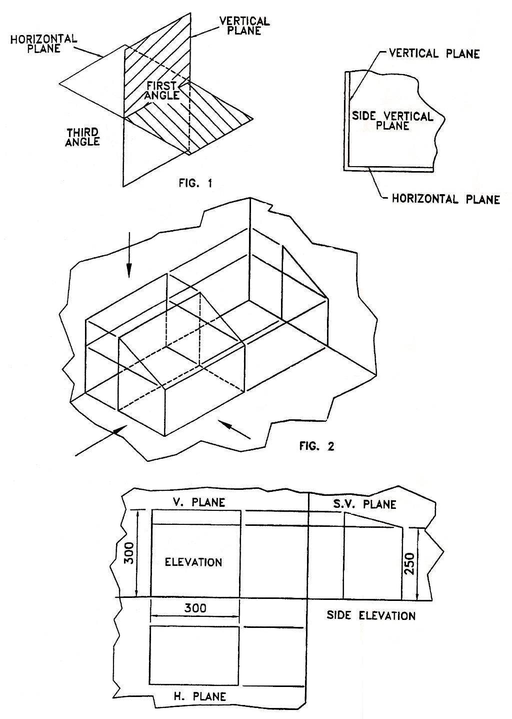
Figure 1 - Orthographic Projection 1
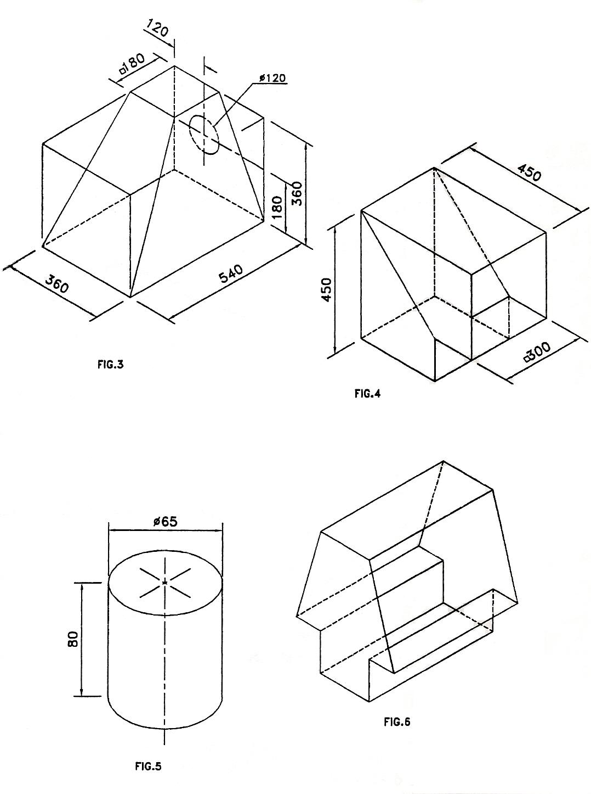
Figure 2 - Orthographic Projection 2
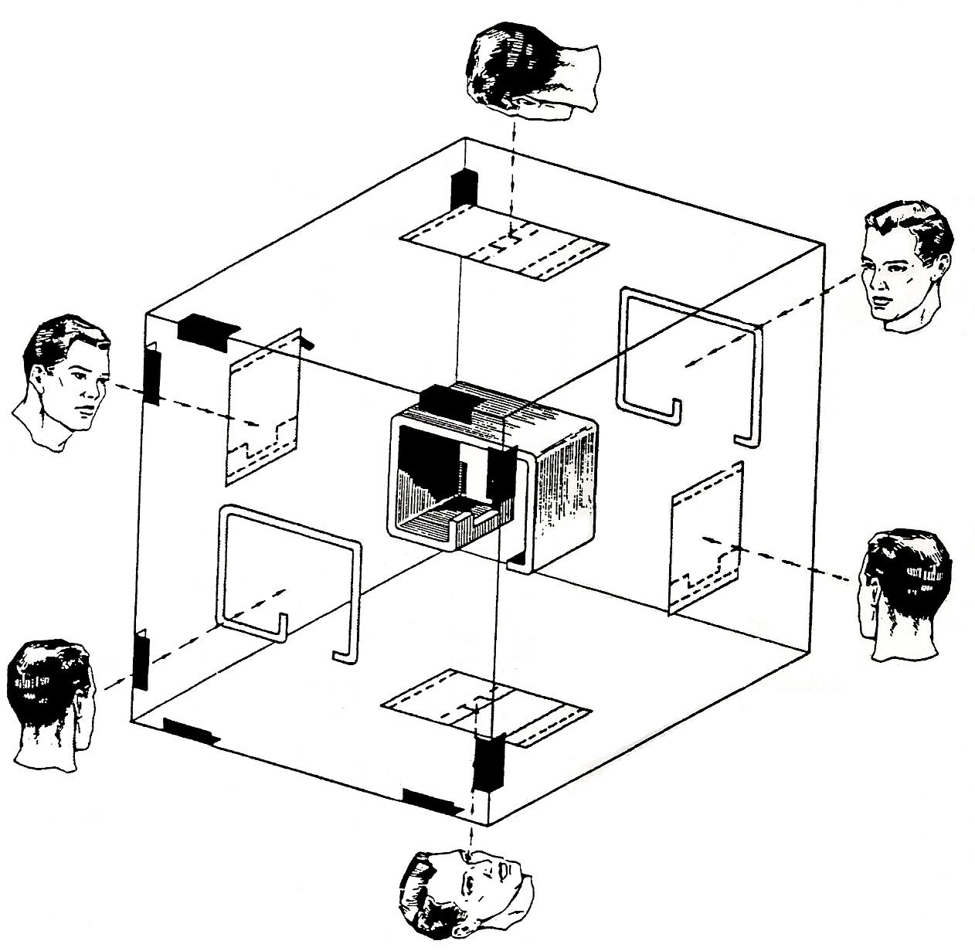
Figure 3 - Visualise the Metal Part Suspended in a Hinged Glass Box

To grasp the theory of orthographic projection, visualise the metal part suspended in a hinged glass box.

Drawing
In order to interpret orthographic drawings correctly it is very important for the craftsman to be able to distinguish between first- and third-angle projections. Any misinterpretation, even of a relatively simple component, will result in some details being fabricated in the Opposite hand. In Figure 5 the same component is shown drawn (a) in first-angle (English) projection, and (b) in third-angle (American) projection, for comparison of the two methods.
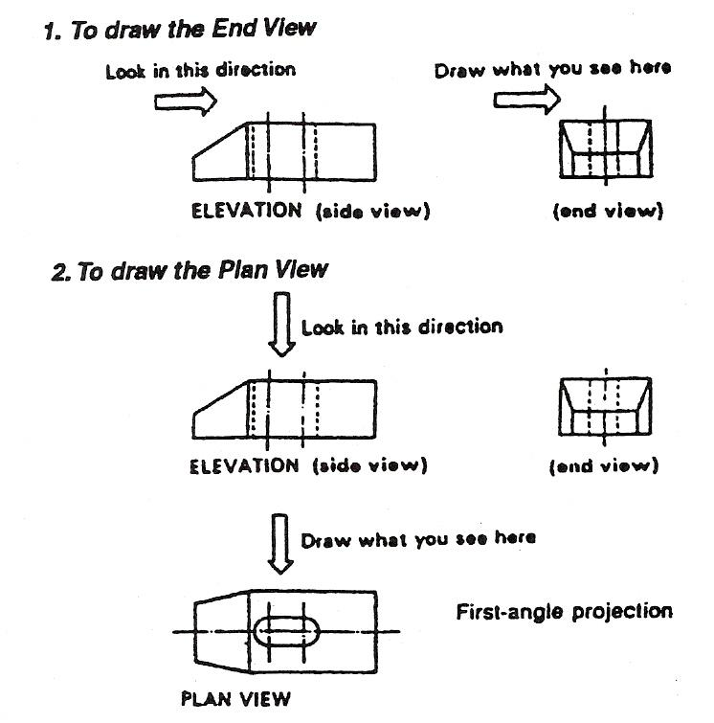
Figure 4 - Orthographic Drawing
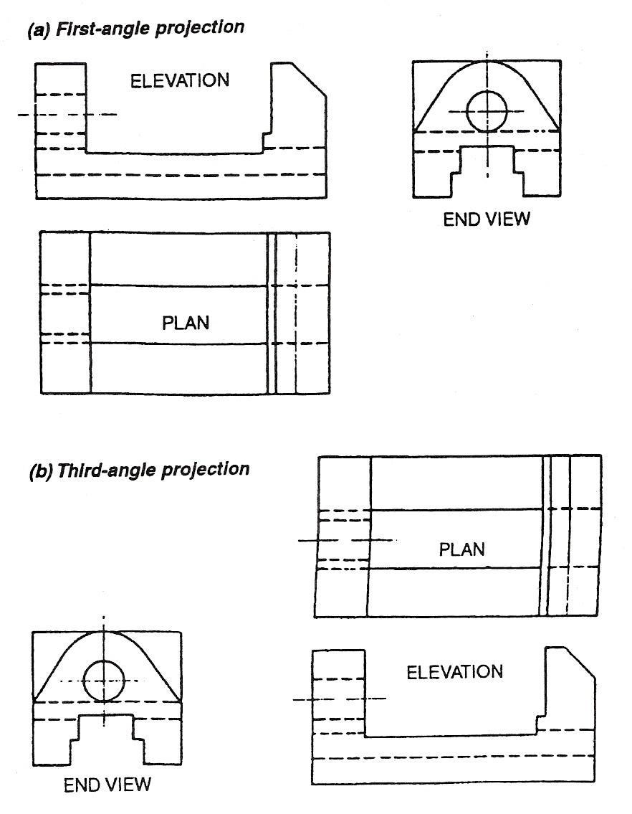
Figure 5 - (a) First-Angle and (b) Third-Angle Projection

Third Angle Projection
It will be noticed in Figure 5 that a drawing in third-angle projection has exactly the same views as the first-angle projection, but the views are positioned in a different relationship to each other. Figure 4 shows how the views are conventionally positioned in a third-angle drawing. Figure 6 illustrates the geometrical construction employed to produce the views given in Figure 4. To avoid confusion the projection used must always be clearly stated on the drawing.
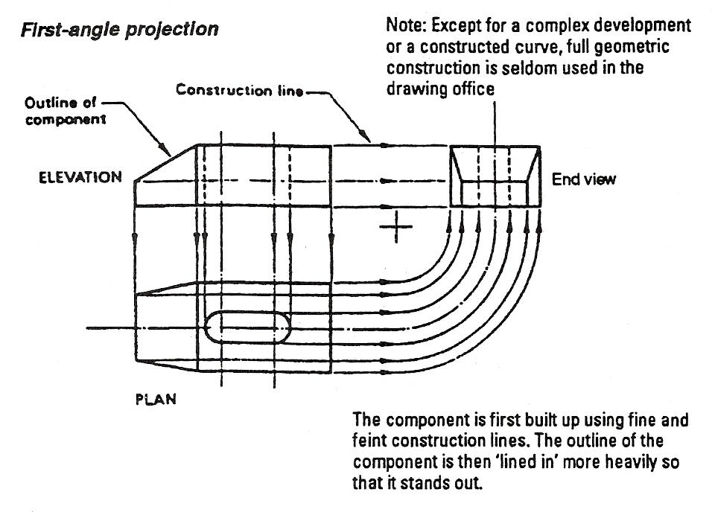
Figure 6 - Orthographic Drawing: Geometric Construction
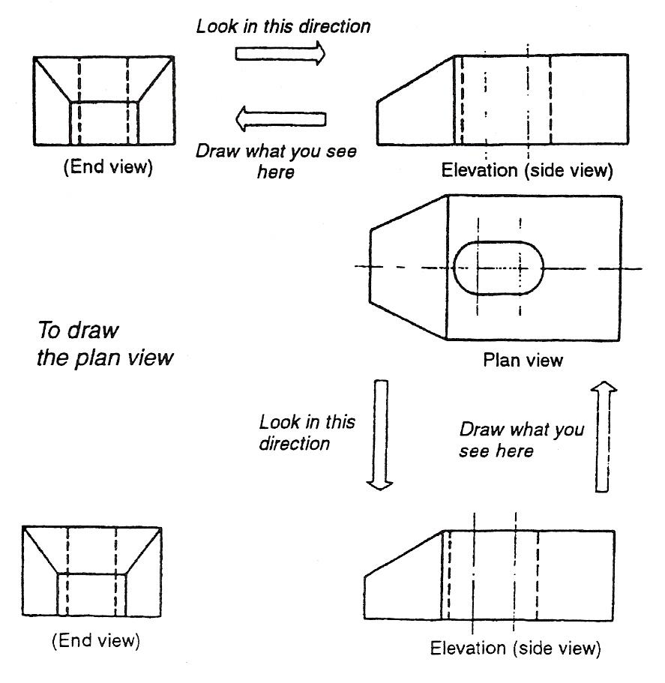
Figure 7 - Third-Angle Orthographic Drawing
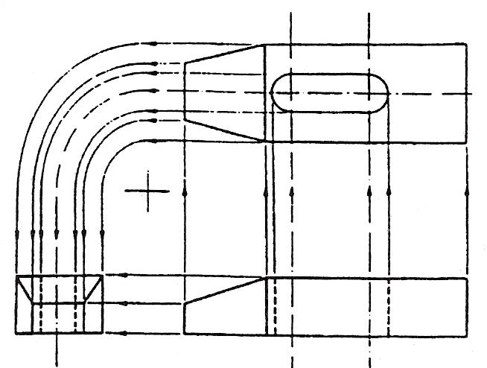
The figure shown here illustrates the geometrical construction used to produce the views given in Figure 7.
The component is first built up using fine and feint construction lines; component is then 'lined in' more heavily so that it stands out.
Note: Except for a complex development or a constructed curve, full geometric construction is seldom used in the drawing office.

Selection of Views
In practical work it is important to choose the combination of views that will describe the shape of a component in the best and most economical way. Often only two views are necessary.
For example, a cylinder, if on a vertical axis, would require only a front elevation and a plan view. If the cylinder is on a horizontal axis, only a front elevation and an end view is required. Conical and pyramidal shapes can also be described by two views. Figure 8 illustrates two-view shapes drawn in third-angle projection.
Sometimes two views are used to describe an object or component on the assumption that the contour in the third direction is of a shape that can naturally be expected. Figure 8 explains why in many cases two views do not fully describe the shape of a component.
The two views shown at (a) would suggest that component 'A' is rectangular and of square cross-section.
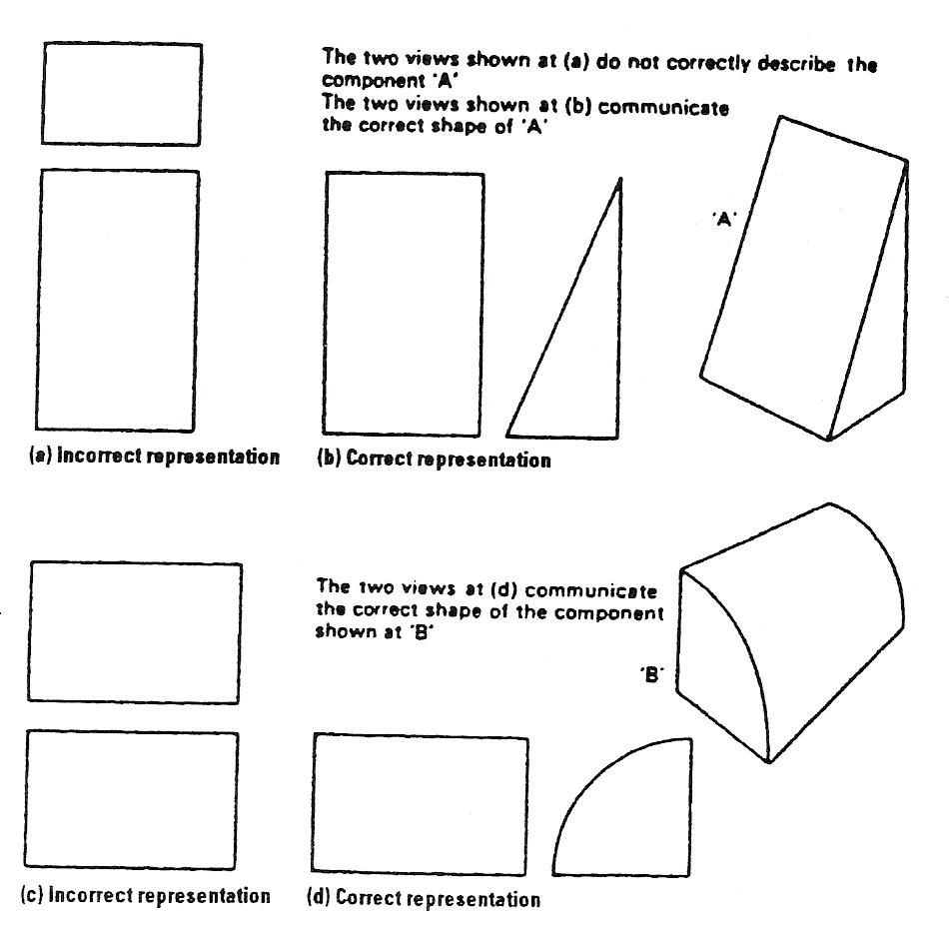
Figure 8 – Two-View Shapes Drawn in Third-Angle
However, these two views may be the front elevation and plan views of the tapering rectangular component 'A' as shown in the two views at (b). The two views of a component shown at (c) do not describe the component at all. It might be assumed to be of square cross-section, but it could as easily be of round, rectangular, quarter-round, or of any other shaped cross-section, which can only be indicated by a side view. The figure at (d) illustrates how the component shown at '8' is clearly described by two views. In practice, any simple component would be visualised mentally and the necessary views selected without a pictorial sketch. However, in more complicated work, a pictorial sketch may be used to advantage. It is never necessary to sketch all possible views in order to make a selection.

Self Assessment

Index

D
Drawing, 12
Selection of Views, 14
Third-Angle Projection, 13

